Lab: EC2 Root Disk Recovery Using Snapshot

Objective
In this lab you will:
- Create an EC2 instance
- Add data to the root disk
- Create a snapshot backup
- Simulate root disk corruption
- Verify the instance cannot be accessed
- Create a new volume from snapshot
- Replace the corrupted root disk
- Start the instance and validate recovery

Resource Naming Convention
Resource | Name Example
EC2 Instance | studentname-ec2
Snapshot | studentname-rootdisk-snapshot
Recovery Volume | studentname-recovery-volume
Example:
saravana-ec2
saravana-rootdisk-snapshot
saravana-recovery-volume

Step 1: Create EC2 Instance
Login to AWS Console.
Go to:
Amazon EC2 → Launch Instance
Configuration:
Setting | Value
Name | studentname-ec2
AMI | Amazon Linux 2
Instance Type | t2.micro
Key Pair | create/select
Network | Default VPC
Storage | 8 GB gp3
Click Launch Instance.
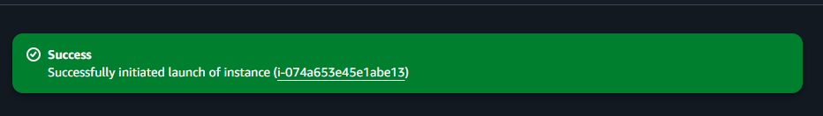

Step 2: Connect to EC2
ssh -i studentkey.pem ec2-user@<public-ip>
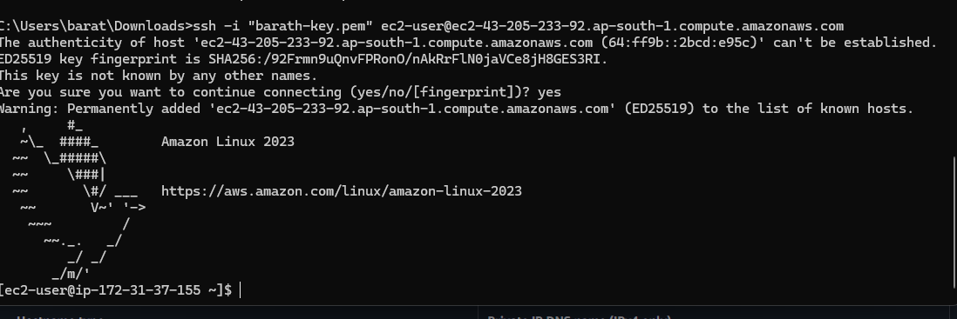

Step 3: Create Test Data
Create some files to simulate application data.
sudo mkdir /labdata

echo "EC2 snapshot recovery lab file" | sudo tee /labdata/file1.txt
echo "Application configuration data" | sudo tee /labdata/file2.txt

ls /labdata
Expected output:
file1.txt
file2.txt
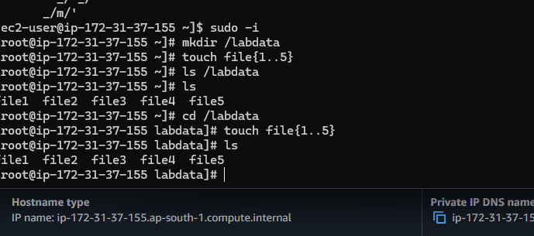

Step 4: Create Snapshot of Root Disk
Go to EC2 Console → Instances
Select:
studentname-ec2
Open Storage tab.
Copy the Root Volume ID.
Navigate to:
EC2 → Volumes
Select the root volume.
Click:
Actions → Create Snapshot
Configuration:
Field | Value
Name | studentname-rootdisk-snapshot
Description | Backup before corruption
Wait until snapshot state = Completed.
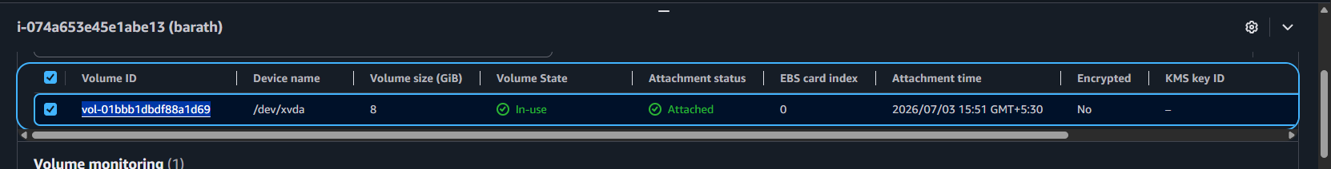
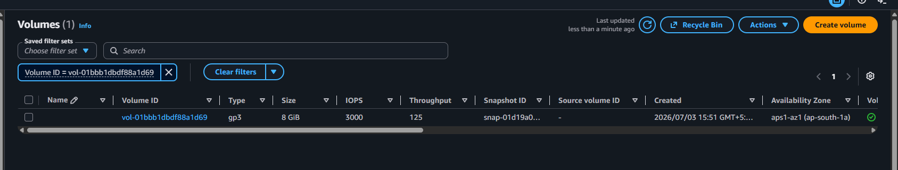
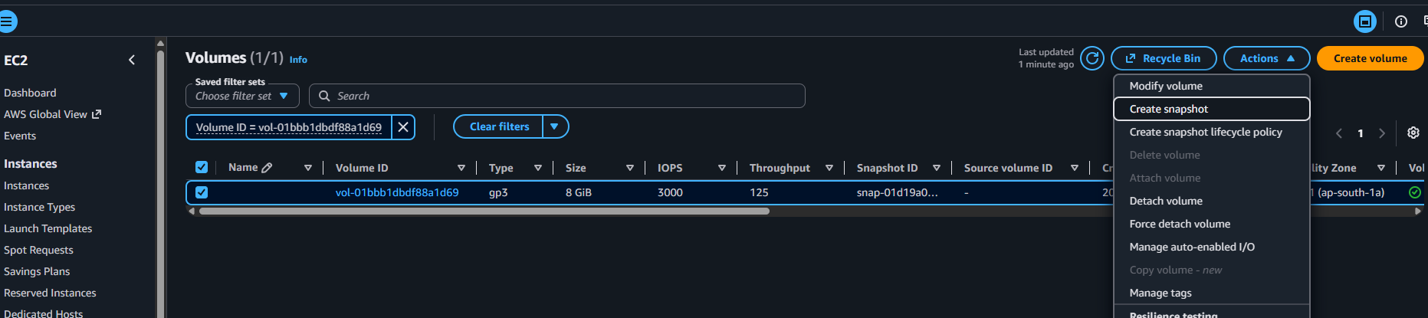
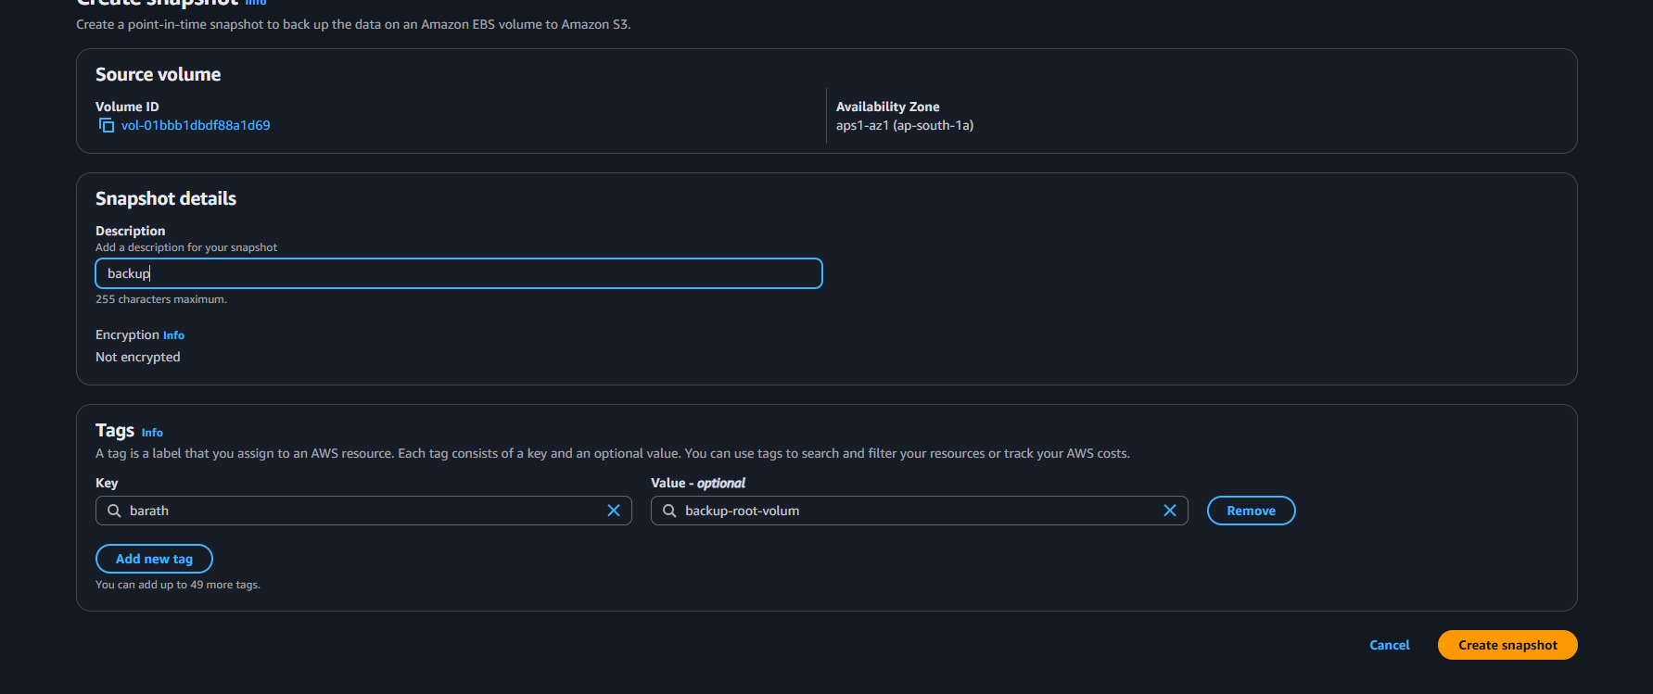

Step 5: Simulate Root Disk Corruption
SSH into the instance.
⚠️ These commands intentionally break the system.
Delete system files:
sudo rm -rf /
Delete boot files:
sudo rm -rf /boot/*
Reboot the system:
sudo shutdown -r now
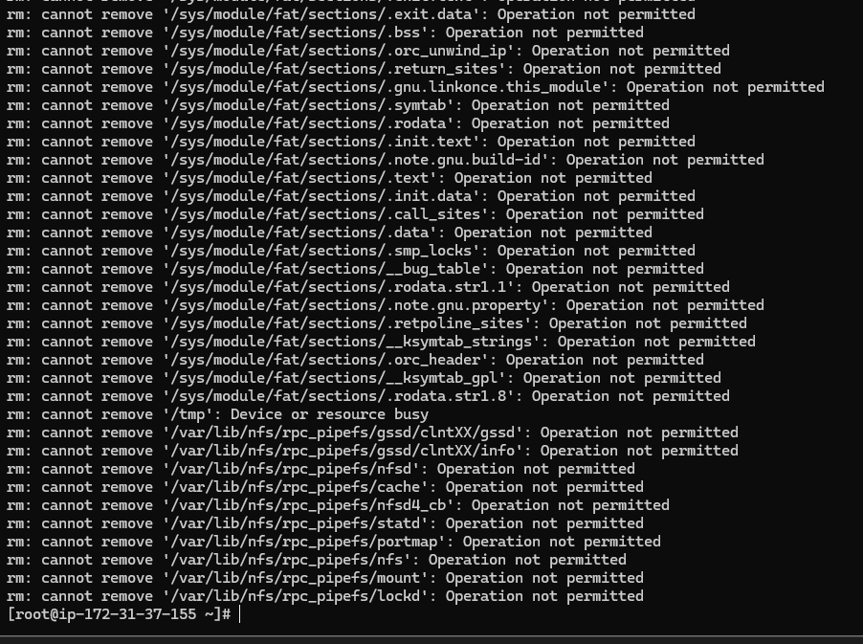

Step 6: Try to Access the Instance
Try SSH again:
ssh -i studentkey.pem ec2-user@<public-ip>
Expected result:
❌ Connection fails or instance fails health checks
This confirms OS disk corruption.

Step 7: Stop the Instance
Go to:
EC2 → Instances
Select:
studentname-ec2
Click:
Instance State → Stop
Wait until instance is stopped.

Step 8: Create New Volume from Snapshot
Navigate to:
EC2 → Snapshots
Select:
studentname-rootdisk-snapshot
Click:
Actions → Create Volume
Configuration:
Field | Value
Name | studentname-recovery-volume
Volume Type | gp3
Availability Zone | Same as EC2
Create the volume.
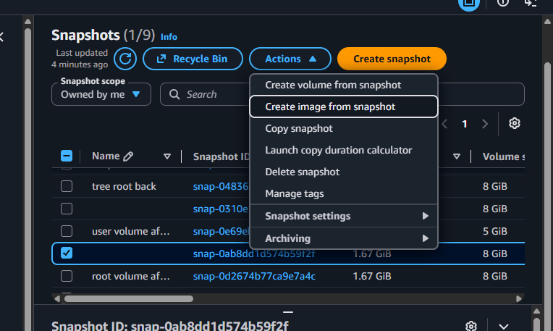
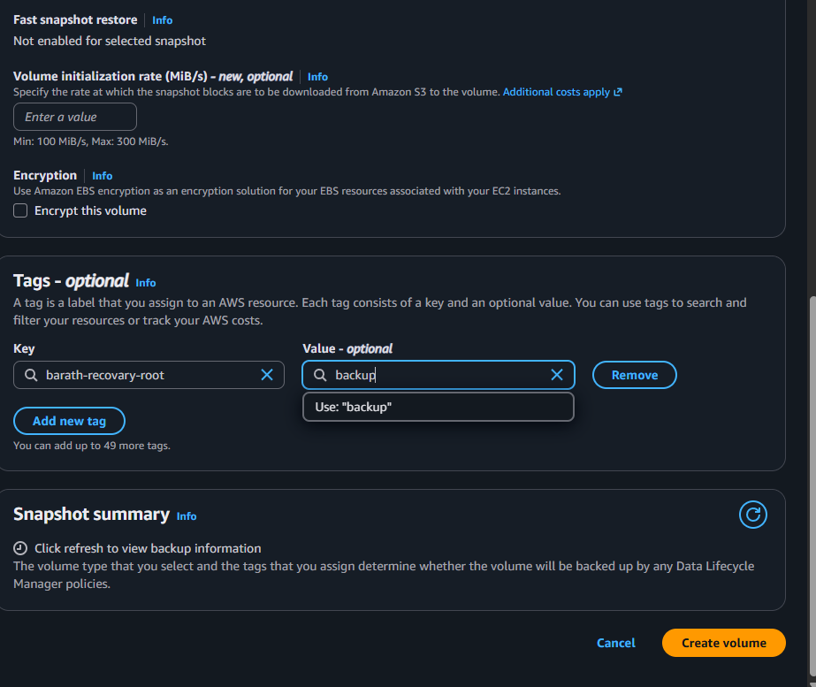
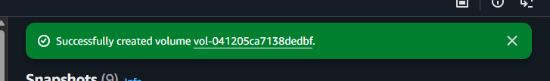

Step 9: Detach Corrupted Root Disk
Go to:
EC2 → Volumes
Find the volume attached to:
studentname-ec2
Example device name:
/dev/xvda
Click:
Actions → Detach Volume
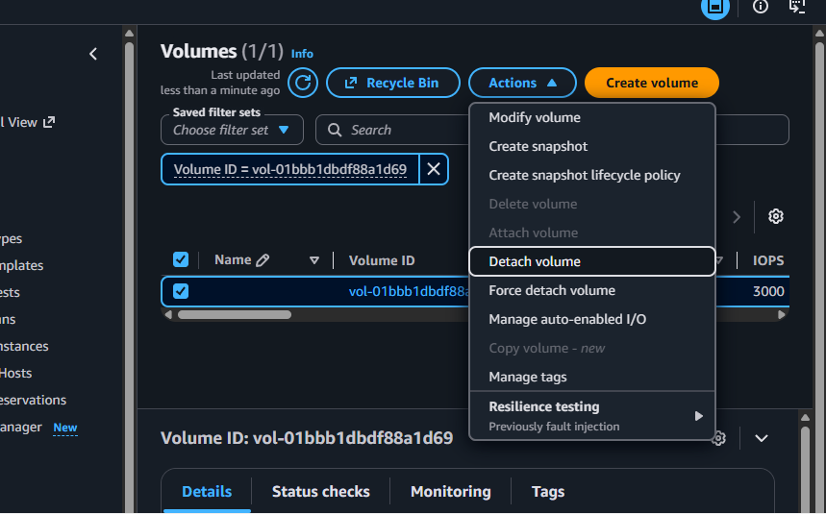

Step 10: Attach Recovery Volume as Root Disk
Select:
studentname-recovery-volume
Click:
Actions → Attach Volume
Configuration:
Field | Value
Instance | studentname-ec2
Device | /dev/xvda
Attach the volume.
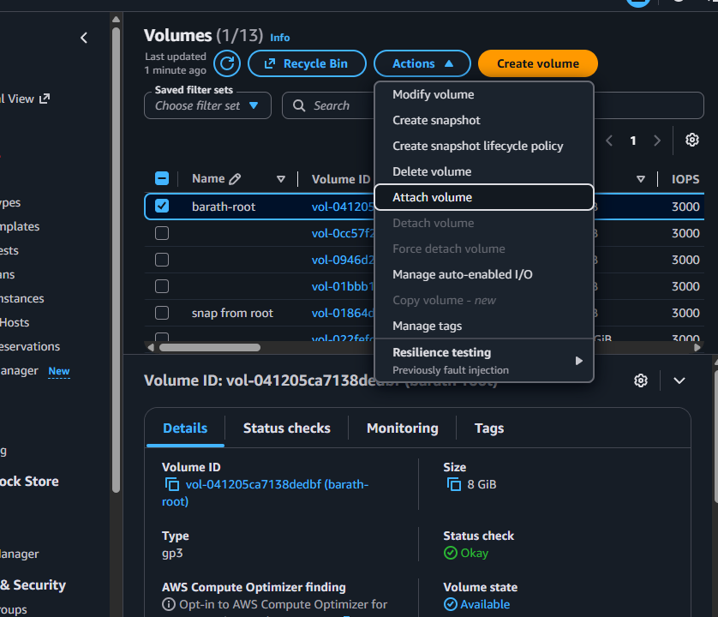
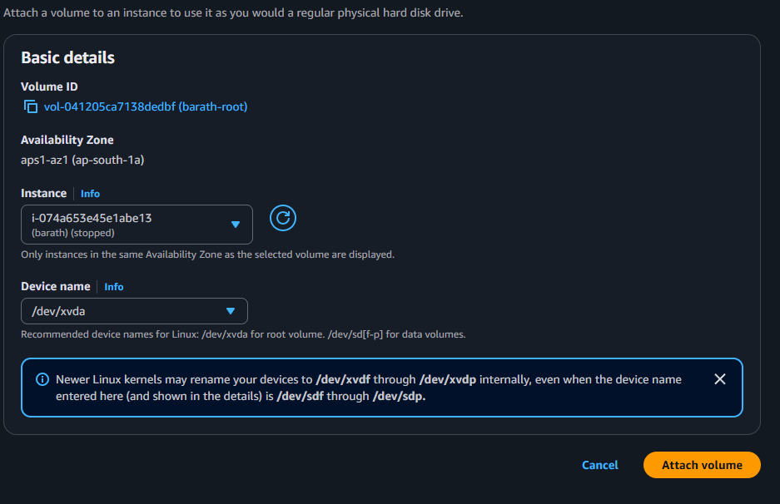

Step 11: Start the Instance
Go to:
EC2 → Instances
Select:
studentname-ec2
Click:
Instance State → Start
Wait until instance is running.

Step 12: Login and Validate
Connect again:
ssh -i studentkey.pem ec2-user@<public-ip>
Check data:
ls /labdata
cat /labdata/file1.txt
Expected output:
EC2 snapshot recovery lab file
This confirms the snapshot successfully restored the OS disk.
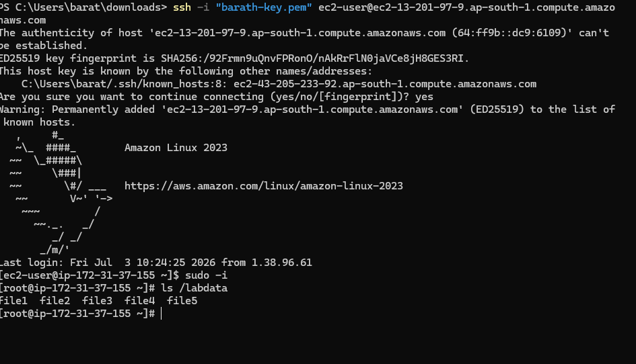

Lab Architecture
studentname-ec2
│
│ Root Volume
│
├── Snapshot Backup
│
▼
Create Volume from Snapshot
│
▼
Detach Corrupted Disk
│
▼
Attach Recovery Disk
│
▼
Start Instance → Data Restored

Validation Checklist
Task | Expected Result
EC2 created | Running
Data added | Files visible
Snapshot created | Completed
Disk corrupted | Instance inaccessible
Recovery volume created | From snapshot
Root disk replaced | Successful
Instance started | Running
Data validated | Files restored

